

**FACULTY OF SCIENCE AND TECHNOLOGY**

**DEPARTMENT OF COMPUTING AND INFORMATICS**

­­­­­­

**GEO-SPECIFIC EMERGENCY MESSAGE BROADCASTING**

**Kimeu Dominic Kiio**

**Registration no: P15/142580/2021**

**Supervisor**

**Dr. Kahonge Andrew M.**

**A second-year project report submitted in partial fulfilment of the requirements for the award of Bachelor of Science in Computer Science of the University of Nairobi.**

**April 2023**

TABLE OF CONTENTS

TABLE OF CONTENTS ii

TABLE OF FIGURES iv

DECLARATION v

DEDICATION vi

ACKNOWLEDGEMENTS vii

ABREVIATIONS viii

CHAPTER 1: INTRODUCTION 1

BACKGROUND 2

PROBLEM STATEMENT 3

PROJECT OBJECTIVES 4

SYSTEM DEVELOPMENT OBJECTIVES 4

RESEARCH OBJECTIVES 4

Methods of research. 4

RESEARCH TOPICS 4

Mobile Carrier Networks 4

Impact of Timely Communication in Emergency Situations 4

PROJECT JUSTIFICATION 5

PROJECT SCOPE 7

Assumptions 7

CHAPTER 2: LITERATURE REVIEW 8

INTRODUCTION 8

SMS-CB IMPLIMENTATION IN THE WORLD 8

FEASIBILITY OF THE PROPOSED SYSTEM 9

Technical Feasibility: 9

Resource Availability: 9

Potential Risks and Mitigation: 9

Conclusion: 10

CHAPTER 3: SYSTEM ANALYSIS AND DESIGN 11

SYSTEM DEVELOPMENT METHODOLOGY 11

The spiral model 11

SYSTEM ANALYSIS 13

Assessment Criteria 13

Information Security 13

Hardware Requirements 13

Software Requirements 13

a) Scalability 14

b) Development Time 14

c) Setup Cost 15

d) System Analysis Model 15

REQUIREMENTS SPECIFICATION 16

• CLIENT (RECEIVER) 16

Functional Requirements 16

Non-functional Requirements 16

Pseudo-requirements 16

• BROADCASTER 16

Functional Requirements 16

Non-Functional Requirements 16

Pseudo-requirements 16

SYSTEM DESIGN 17

System Architecture Design 17

DATABASE DESIGN 18

UI DESIGN 18

REFERENCES 20

APPENDIX A: USER MANUAL 21

APPENDIX B: SAMPLE CODE 22

TABLE OF FIGURES

Figure 1: System Analysis: Project Timeline 7

Figure 2: System Analysis: Gantt Chart 8

Figure 3: System Design: System Architecture Overview 9

DECLARATION

I hereby declare that this project is my own work, and has to the best of my knowledge, not been submitted to any other institution of higher learning.

**Student:** Kimeu Dominic Kiio **Reg No:** P15/142580/2021

**Signature:**

**Date:**

This project has been submitted as a partial fulfilment of requirements for the Bachelor of Science in Computer Science of the University of Nairobi with my approval and the University Supervisor.

**Supervisor:** Dr. Kahonge Andrew M.

**Signature:**

**Date:**

DEDICATION

This dedication is a heartfelt recognition and gratitude towards the professors, lecturers, faculty staff, and colleagues who have played a crucial role in bringing the project to fruition. Their unwavering commitment provided valuable critiques, encouragement, and inspiration, motivating me to bring the project to fruition. Their support and insights have been instrumental in shaping the project's success. This dedication serves as a tribute to their belief, challenges, and unwavering support, which have made this project a reality and inspired further achievements.

ACKNOWLEDGEMENTS

I would like to express my heartfelt gratitude to my incredible family, whose unwavering support and understanding have been instrumental in my journey. Their encouragement and love have fuelled my determination to achieve my goals. I am also immensely thankful to my dedicated project supervisor, whose guidance and expertise have been invaluable throughout this endeavour. Their insights and mentorship have played a significant role in shaping the success of this project.

Furthermore, I would like to extend my appreciation to my amazing colleagues who have been with me every step of the way. Their encouragement and camaraderie have made this journey not only productive but also enjoyable.

ABREVIATIONS

**SMS –** Short Messaging Service

**SMS-CB –** Short Messaging Service – Cell Broadcast

**SMS-PP –** Short Messaging Service - Peer to Peer

**UI –** User Interface

**HTML 5 –** Hyper-Text Markup Language Version 5

**CSS 3 –** Cascading Style Sheets Version 3

**JS –** Java Script

**API –** Application Programming Interface

CHAPTER 1: INTRODUCTION

The objective of this project is to develop a emulation system for SMS-CB using a server client model. The proposed system will enable the emulation of cell broadcasting functionality in a controlled and reproducible environment. Broadcasting is a method to reach multiple mobile telephone users in a defined area at the same time by sending a common information packet. This is achieved using SMS-CB technology. A local report conducted by the CAK established that a majority of Kenyans have access to a mobile phone (Directly or indirectly), each phone therefore being a suitable candidate for SMS-CB. Utilizing this feature, we could potentially use it to send near real time messages to persons in a defined area of interest whilst still maintaining their anonymity. Access to information this quick could potentially save lives or perform quick damage control in such an area.

BACKGROUND

Having the ability to quickly and efficiently send emergency alerts to the general public in multiple scenarios is an indispensable asset. The systems currently in place: breaking news, social media, and public address systems fall short when the timeliness of delivering the message is of great concern.

Currently, there is no system that can quickly dispense information in near-real time. Despite this, a 2020-2021 report conducted by the Communications Authority of Kenya (CAK) showed that there were 64,205,721 active mobile telephony subscriptions at the end of 2021 ***(“Communications Authority of Kenya Annual Report and Financial Statements 2020-2021,” n.d.).*** According to the same report, only less than 3.4% of the population have zero access to 2G networks while attaining 96.6% population coverage. The total geographical coverage is at 56.5%.

Hence with this almost complete population coverage, utilizing mobile carrier networks to send Short Messaging Service-Cell Broadcast messages will enable the relevant parties to reach the mobile users in a defined area at the same time. The relevant parties being: law enforcement, the fire brigade, weather forecasters, medical practitioners etc.

Unlike a normal SMS-PP which is peer to peer, Cell Broadcast (CB) is a one to many geo-targeted and geo-fenced messaging service. SMS-CB messages are directed to base station radio cells or multiple bases stations rather than specific telephones. This maintains recipient anonymity whilst reaching the intended recipients in a given area or zone. Once a CB message is initiated, it can be repeated indefinitely. The recipients that have already received it can simply discard the message because it maintains a list of the serial numbers of received CB messages. This allows for recipients moving into the zone or whose connection was down to be able to receive the message for as long as the CB message is repeated.

In the event of a crisis, SMS-CB is a highly effective communication channel because it does not use the same communication channel routes for services such as social media and the internet. It can therefore reach a large number of people without overloading the network.

In this project, I have chosen to emulate SMS-CB using a server client architecture that will cater for interactions between mobile and base stations.

PROBLEM STATEMENT

The absence of a near-real-time communication service for dispensing emergency broadcast information to the public in Kenya poses a significant challenge. Current communication channels, such as local news media, international news, newspapers, and social media posts, fail to provide timely updates during critical situations. This lack of timely information hampers immediate action and damage control efforts, as the ability to receive crucial information earlier could mitigate the extent of potential harm or damage.

In contrast, developed regions have implemented SMS-CB (Cell Broadcast) technology to offer prompt emergency communication services. SMS-CB enables the broadcasting of messages to all mobile devices within a specified geographic area, ensuring quick dissemination of critical information. However, due to the proprietary nature of the hardware and software used by carrier networks in Kenya, implementing SMS-CB directly is not feasible.

To address this challenge, a server-client architecture is proposed as an emulation of SMS-CB technology. By developing a system that replicates the functionality of SMS-CB, emergency broadcast information can be efficiently and swiftly distributed to the public in Kenya. This project aims to establish a reliable and near-real-time communication service that overcomes the limitations of existing channels, allowing for timely information dissemination during emergencies and enabling prompt responses for effective damage control.

PROJECT OBJECTIVES

SYSTEM DEVELOPMENT OBJECTIVES

RESEARCH OBJECTIVES

My set research objectives were as follows:

* Research on the impact timely communication in the success of responding and dealing with emergency situations.
* Research on how mobile carrier networks communicate with connected clients and deal with handovers.

Methods of research.

The methods I employed in uncovering the functionalities and technical requirements that the system would need was through unobtrusive methods.

Reading through technical tools documentation and research papers on the subject matter helped me realise my requirements.

Using this information, I was able to come up with the following use cases and scenarios.

RESEARCH TOPICS

Mobile Carrier Networks

Impact of Timely Communication in Emergency Situations

The impact of timely communication in emergency situations cannot be overstated, as it plays a crucial role in minimizing risks, coordinating response efforts, and ultimately saving lives. Here are a few examples and sources highlighting the significance of timely communication during emergencies:

1. Timely alerts for natural disasters: In regions prone to natural disasters such as earthquakes, hurricanes, or floods, timely communication can provide early warnings and critical information to at-risk populations. Studies have shown that early warning systems and timely communication significantly reduce the number of casualties and enhance preparedness levels (Source: UNISDR, "Sendai Framework for Disaster Risk Reduction 2015-2030").
2. Rapid response to medical emergencies: Timely communication is vital in medical emergencies, where immediate action can make a life-or-death difference. For instance, the American Heart Association emphasizes the importance of promptly activating emergency medical services (EMS) during a suspected cardiac event. Early notification enables EMS providers to arrive quickly, administer lifesaving interventions, and increase the chances of survival (Source: American Heart Association, "Emergency Medical Services Systems").
3. Public safety and crime prevention: In emergency situations involving public safety, timely communication is crucial for alerting the public to potential threats and enabling them to take appropriate actions. For example, in the case of active shooter incidents, immediate notifications through various channels, such as mobile alerts or public address systems, help people seek shelter or evacuate, potentially minimizing casualties (Source: Federal Emergency Management Agency, "Active Shooter: How to Respond").
4. Timely evacuation and disaster response: During large-scale disasters like wildfires or industrial accidents, timely communication is essential for organizing and executing evacuation plans effectively. Providing clear instructions, evacuation routes, and updates on the evolving situation helps ensure the safe evacuation of affected communities. Research has shown that effective communication during evacuations improves compliance and reduces confusion and panic (Source: National Academies of Sciences, Engineering, and Medicine, "A Framework for Assessing Improvements to Emergency Operations Plans for Evacuations").
5. Containing the spread of infectious diseases: During outbreaks or pandemics, timely communication of accurate information is vital to contain the spread of infectious diseases. Public health agencies and authorities need to disseminate updates on the disease, preventive measures, and treatment options promptly. This helps raise awareness, encourages compliance with preventive measures, and enables individuals to seek appropriate medical care (Source: World Health Organization, "Risk Communication in Public Health Emergencies: A Field Guide").

In summary, timely communication in emergency situations has a significant impact on saving lives, minimizing risks, and enhancing overall response efforts. Whether it is providing early warnings, facilitating rapid medical responses, ensuring public safety, enabling effective evacuations, or containing the spread of diseases, timely communication plays a vital role in mitigating the impact of emergencies and protecting communities.

PROJECT JUSTIFICATION

Project Justification:

The proposed project aims to develop model to address the critical need for timely communication of emergency broadcast information to the public in Kenya. The project justification is based on the following key factors:

Problem Identification: Currently, there is a lack of near-real-time communication services for dispensing emergency broadcast information to the public in Kenya. This hinders immediate action and damage control efforts, where early dissemination of information is crucial for minimizing harm.

Relevance of SMS-CB Technology: SMS-CB technology has proven effective in other parts of the world for providing prompt emergency communication services. By leveraging this technology, it becomes possible to broadcast messages to all mobile devices within a specified geographic area, ensuring rapid dissemination of critical information. Implementing SMS-CB in Kenya can significantly improve the efficiency and effectiveness of emergency communication.

Emulation using Server-Client Model: Given the proprietary nature of the hardware and software used by carrier networks in Kenya, emulating SMS-CB using a server-client architecture is a viable solution. This approach allows for the replication of SMS-CB functionality, enabling efficient and near-real-time communication of emergency broadcast information.

Anticipated Benefits: The implementation of an SMS-CB emulation system using the server-client model will have significant benefits. Timely communication of emergency broadcast information can save lives, enhance preparedness, and minimize risks during critical situations. The system will facilitate prompt dissemination of vital information, enabling the public to respond quickly and appropriately.

Feasibility and Cost-Benefit Analysis: The project is deemed feasible as it utilizes existing technologies and infrastructure, leveraging the server-client model for emulation. The cost-benefit analysis demonstrates that the benefits of timely emergency communication, such as reduced casualties, improved response coordination, and potential damage control, outweigh the investment required for implementing the emulation system.

The proposed SMS-CB emulation project utilizing the server-client model addresses the critical need for timely communication of emergency broadcast information to the public in Kenya. By replicating the functionality of SMS-CB, the project will enable efficient and near-real-time dissemination of critical information, empowering the public to take immediate action during emergencies. The project aligns with organizational objectives, ensures the feasibility of implementation, and offers substantial benefits, making it a valuable investment for enhancing public safety and emergency response capabilities in Kenya.

PROJECT SCOPE

The scope of the project has been constrained to the Nairobi City County.

The support test data as well is limited to 3 carrier types, each with 3 base stations.

Each of the three base stations have three cells each with varying capacities.

Assumptions

This project assumes access to the internet for both the client and broadcaster.   
It also assumes all input entered is always in the appropriate format with correct values.

CHAPTER 2: LITERATURE REVIEW

INTRODUCTION

The implementation of SMS-CB (Cell Broadcast) technology in various locations has proven to be advantageous in enhancing emergency communication and response systems. This review explores real-world implementations of SMS-CB. Furthermore, it highlights scenarios where SMS-CB was utilized and demonstrates the advantages it offered in those situations.

SMS-CB IMPLIMENTATION IN THE WORLD

**Japan:**

Japan is recognized as one of the pioneers in implementing SMS-CB technology for disaster warning systems. The country has an extensive network that utilizes cell broadcasting to deliver emergency alerts to mobile devices in targeted areas. The Japan Meteorological Agency (JMA) sends out alerts for earthquakes, tsunamis, and severe weather conditions. The SMS-CB system has played a crucial role in minimizing casualties and improving disaster preparedness (Source: Cabinet Office of Japan, "Disaster Management in Japan").

**Netherlands:**

The Netherlands has implemented an SMS-CB system known as NL-Alert. This system enables government agencies to broadcast emergency messages to all mobile devices within a specific region during critical situations. NL-Alert has been utilized for various emergencies, including severe weather warnings, terrorist threats, and major accidents. It provides timely information to the public, allowing them to take appropriate actions and stay safe (Source: Government of the Netherlands, "NL-Alert").

**United States:**

The United States employs SMS-CB technology through the Wireless Emergency Alerts (WEA) system. WEA enables authorized government agencies to send geographically targeted alerts to mobile devices in specific regions. This system has been used for various emergencies, such as Amber Alerts for missing children, severe weather warnings, and Presidential alerts. WEA has proven effective in rapidly disseminating critical information to the public, enhancing public safety and emergency response (Source: Federal Communications Commission, "Wireless Emergency Alerts").

**Conclusion:**

The implementation of SMS-CB technology in various real-world locations has demonstrated its advantages in emergency communication scenarios. By leveraging SMS-CB, countries like Japan, the Netherlands, and the United States have improved their emergency warning systems, enabling timely dissemination of critical information to the public. Whether it is for issuing evacuation orders during wildfires, delivering severe weather warnings, or notifying the public about public safety concerns, SMS-CB has proven to be an effective tool for enhancing emergency response, minimizing risks, and ultimately saving lives.

FEASIBILITY OF THE PROPOSED SYSTEM

Technical Feasibility:

The project's technical feasibility revolves around the emulation of SMS-CB functionality using a server-client model. This approach leverages existing hardware and software infrastructure, making it technically feasible to replicate SMS-CB capabilities without reliance on proprietary carrier networks.

Resource Availability:

Successful project implementation relies on the availability of necessary resources, including financial, human, and technical resources. Financially, the project will require investment in server infrastructure, software development, testing, and maintenance. Human resources will be needed for project management, software development, system administration, and ongoing support.

Potential Risks and Mitigation:

It is essential to identify potential risks and develop mitigation strategies to ensure project feasibility. Risks may include technical complexities, compatibility issues with diverse mobile devices, network connectivity limitations, and security vulnerabilities.

Misuse of the system for targeted advertising is also a possibility.

Mitigation measures can include thorough testing and quality assurance processes, regular updates to address compatibility issues, collaboration with network providers to ensure connectivity, and implementation of robust security measures to protect user information and prevent misuse.

Conclusion:

Based on the analysis conducted, the proposed project demonstrates strong feasibility. Considering the positive, the proposed SMS-CB emulation project is deemed feasible and holds great potential for improving emergency communication and response capabilities in Kenya.

CHAPTER 3: SYSTEM ANALYSIS AND DESIGN

SYSTEM DEVELOPMENT METHODOLOGY

The spiral model

The system development for the project in Kenya follows the Spiral Model, which is an iterative and risk-driven approach. The development process involves several key stages, including planning, risk analysis, prototyping, and evaluation, allowing for incremental improvements and risk mitigation throughout the project's lifecycle.

**Planning:**

The planning phase entails defining project objectives and establishing the overall project plan. Key activities include gathering requirements, specifying system functionalities, and determining project scope and constraints. In this stage a preliminary analysis of the technical feasibility, resource requirements, and potential risks associated with the emulation system are considered.

**Risk Analysis:**

The Spiral Model emphasizes risk analysis and management at each iteration. During this phase potential risks are evaluated and strategies developed to mitigate them. Risks specific to the project may include technical complexities, compatibility issues, network connectivity limitations, and security vulnerabilities. Risk analysis enables the team to prioritize and address risks effectively throughout the development process.

**Prototyping:**

In the prototyping stage, a working prototype of the SMS-CB emulation system is developed. The team focuses on implementing the core functionalities of the server-client architecture and integrating it with existing infrastructure. The prototype is then subjected to rigorous testing and evaluation to ensure that it meets the required specifications and performance criteria. Feedback from users, stakeholders, and system testers is collected and incorporated into subsequent iterations.

**Evaluation:**

The evaluation phase involves a comprehensive assessment of the prototype's performance, usability, and compliance with project requirements. The system is tested for reliability, scalability, and security. User acceptance testing is conducted to gather feedback and validate the system's effectiveness in delivering emergency broadcast information. Based on the evaluation results, necessary refinements and enhancements are identified, and changes are made to the system to address any identified issues or gaps.

**Iterative Development:**

The Spiral Model follows an iterative approach, where each iteration involves a cycle of planning, risk analysis, prototyping, and evaluation. As the project progresses, the system evolves through incremental improvements and refinements based on user feedback and changing requirements. This iterative development approach allows for flexibility and adaptation, ensuring that the final system meets the desired objectives and user expectations.

By adopting the Spiral Model, the system development ensures a systematic and iterative approach.

SYSTEM ANALYSIS

The proposed requirements and functionality need to be analysed to test their feasibility and remove any inconsistencies and incompleteness that may exist.

Assessment Criteria

* Information Security
* Hardware Requirements
* Software Requirements
* Scalability
* Development Time
* Setup Cost
* System Analysis Model

Information Security

No client sensitive client information is stored as the system leaves managing the clients to the carriers. The recipients remain anonymous and no information is sent back to the broadcaster as to whom the message is received by in order to maintain anonymity.

Hardware Requirements

To achieve the required system, the following were deemed to be the required hardware specifications:

* An AMD Ryzen 5 personal computer to develop the software
* The same computer will be used as the server hardware
* An android device running version 7+

Software Requirements

To achieve the required system, the following were deemed to be the required software specifications:

* Eclipse CDT IDE to test, run and debug the code
* VS Code text editor to write, edit and maintain the code
* A Fedora Linux OS to act as the server host as well as run the development software.
* MariaDB Relational Database Management System to store the system data
* HTML, CSS and JS for web app development
* Kotlin for mobile development.
* NodeJS for server-side scripting.

1. Scalability

The scalability of the project to handle multiple users was considered as the server software could be deployed on a more capable server if need be.

1. Development Time

A project Gantt chart together with an outline on time spent will be used to keep track of progress as well as offer milestones and timelines.

|  |  |  |  |  |  |  |  |  |
| --- | --- | --- | --- | --- | --- | --- | --- | --- |
| **Task No:** | **Task Name** | **Planned Hours** | **Actual Hours** | **Planned Start Date** | **Actual Start Date** | **Planned End Date** | **Actual End Date** | **Deliverables** |
| 1. | Prepare a project proposal document. | 2 | 3 | 16-02-2023 | 16-02-2023 | 18-02-2023 | 16-02-2023 | Project Proposal |
| 2. | Research topic 2 and 3 | 10 |  | 18-02-2023 |  | 20-03-2023 |  | Literature Review Documents |
| 3. | Requirements Elicitation | 10 |  | 18-02-2023 |  | 21-02-2023 |  | Use cases and scenarios |
| 4. | System Design | 30 |  | 22-02-2023 |  | 08-03-2023 |  | UML diagrams, network diagrams, database design, code design |
| 5. | Coding | 60 |  | 1-03-2023 |  | 31-03-2023 |  | Progress reports |
| 6. | Testing | 50 |  | 15-03-2023 |  | 7-04-2023 |  | Unit test results, use case review, performance tests |
| 7. | Implementation | 5 |  | 22-03-2023 |  | 31-03-2023 |  | A working system |
| 8. | Prepare a Project Report | 10 |  | 01-03-2023 |  | 10-04-2023 |  | Project report |
|  |  |  |  |  |  |  |  |  |
|  |  |  |  |  |  |  |  |  |
|  |  |  |  |  |  |  |  |  |
|  |  |  |  |  |  |  |  |  |
|  |  |  |  |  |  |  |  |  |
|  | Total Hours | ~222 |  |  |  |  |  |  |

Figure 1: System Analysis: Project Timeline

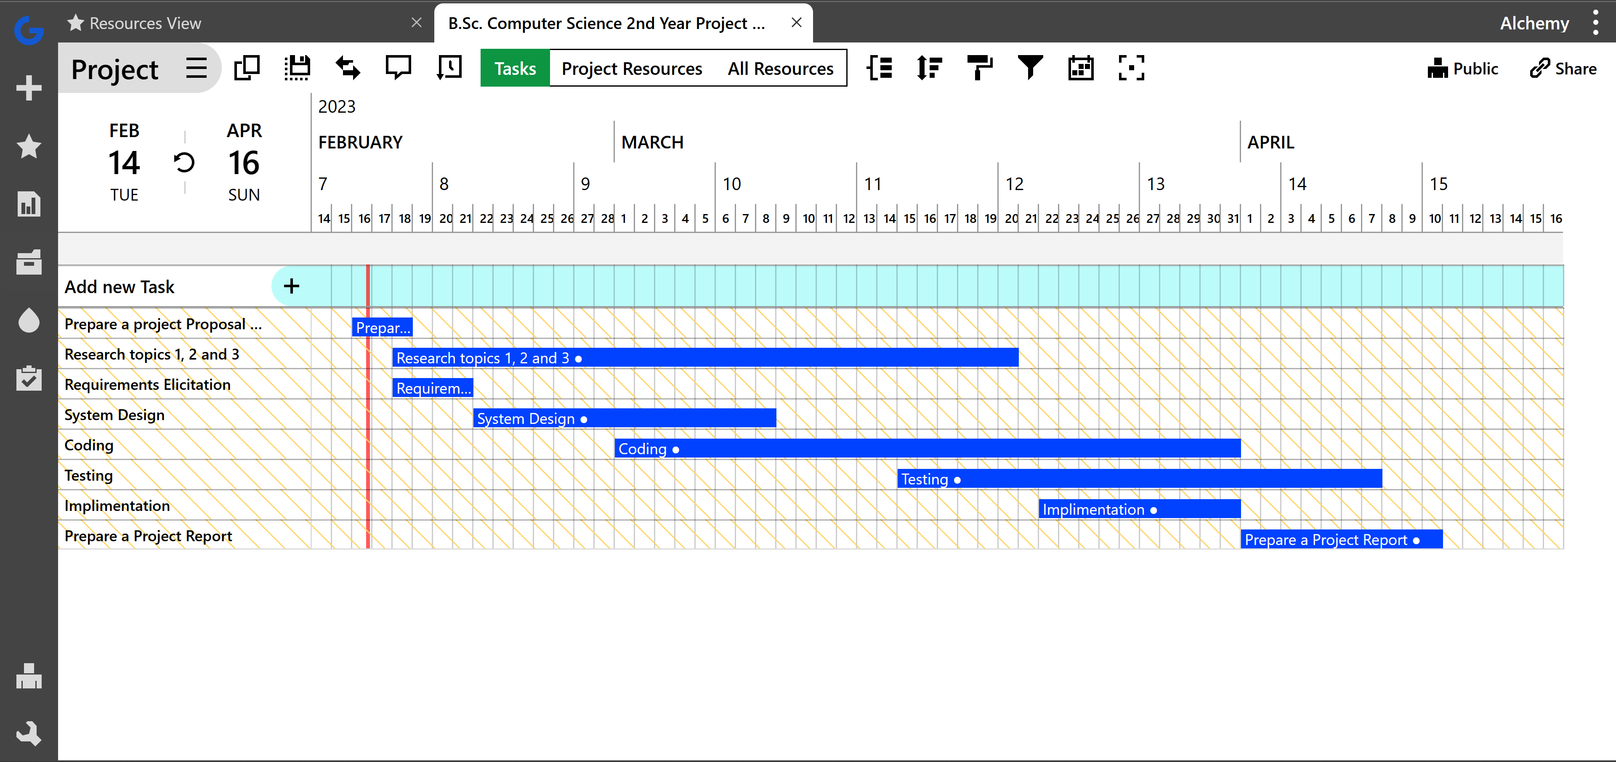

Figure 2: System Analysis: Gantt Chart

1. Setup Cost

It being a relatively small project with already pre-owned hardware, free and open-source software, it will incur no cost to set up.

1. System Analysis Model

A set of system analysis models will be provided during the project timeline in accordance with the set milestones. Refer to Figure 1.

REQUIREMENTS SPECIFICATION

I realised there required two modules, one for the broadcaster and the other for the recipient. The recipient would be interacting with a mobile device whilst the broadcaster a web platform.

* CLIENT (RECEIVER)

Functional Requirements

* Receive broadcast messages.
* Manage received messages.

Non-functional Requirements

* Should be able to discard duplicate incoming messages.
* Should be able to retrieve broadcast messages even after the fact.

Pseudo-requirements

* Should be available on a mobile platform.
* BROADCASTER

Functional Requirements

* Define broadcast zones.
* Send broadcast messages.
* Define carriers.
* Define base stations.
* Define cells.

Non-Functional Requirements

* Should be able to repeat broadcast messages indefinitely.
* Common zones should be able to replicate easily over and over.

Pseudo-requirements

* Should be available on a web-platform

SYSTEM DESIGN

System Architecture Design

The overview of the system is as follows.

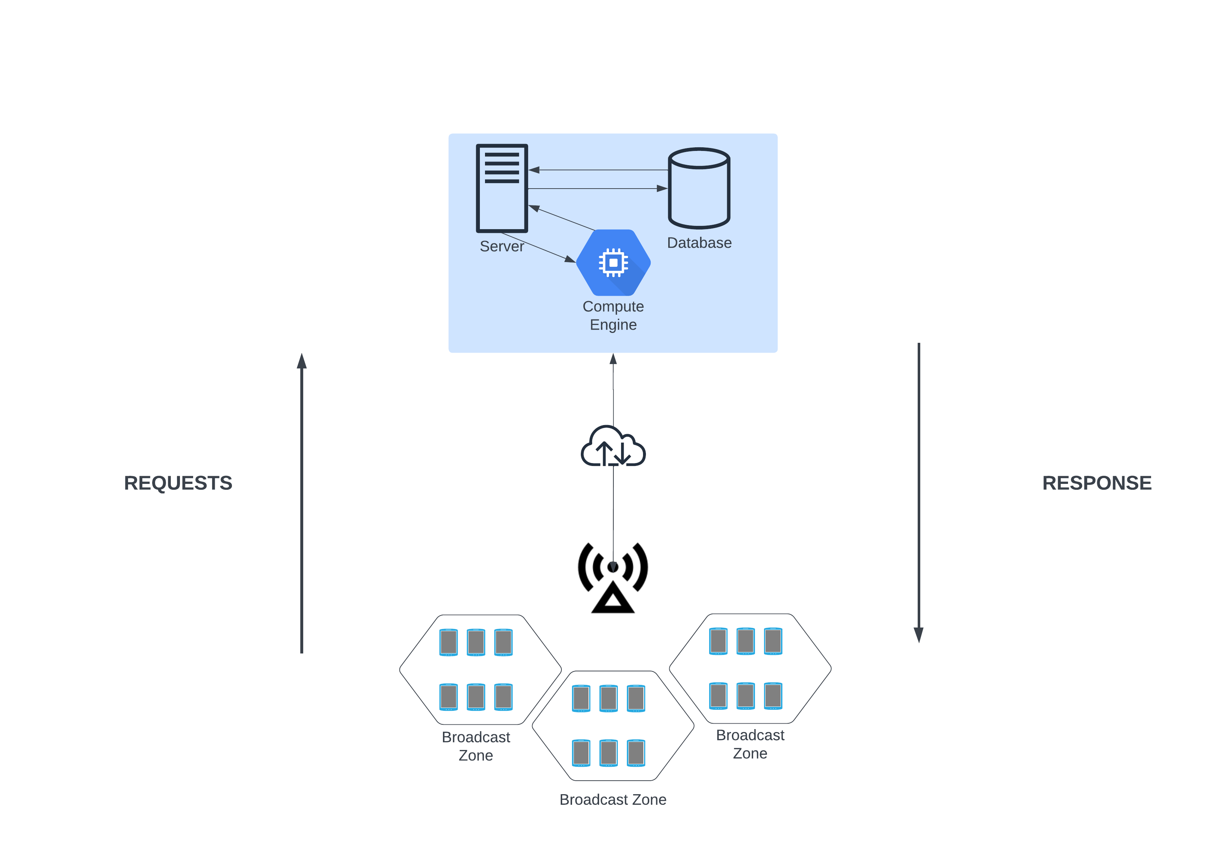

Figure 3: System Design: System Architecture Overview

As defined above, the basic system architecture is as displayed.

The system runs on a NodeJS server. The server hosts a MariaDB relational database that stores all the necessary information to run the project.

A web module (the broadcasters view) contains csv and single-entry input to enter carrier, client and broadcast zone information.

A mobile client receives the most recent broadcast it is allocated.

TECHNOLOGIES USED

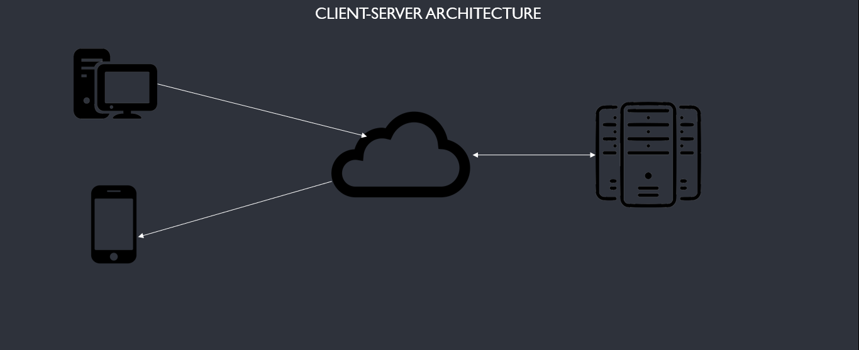

Figure 4: Basic System Structure Overlay

The system is a basic client-server configuration with the following architecture. The server, client and web platform are discussed below:

* Server Technologies

The system server runs on NodeJS on port 55555. It handles all API endpoints for both the web and mobile client.

Its structure is as follows:

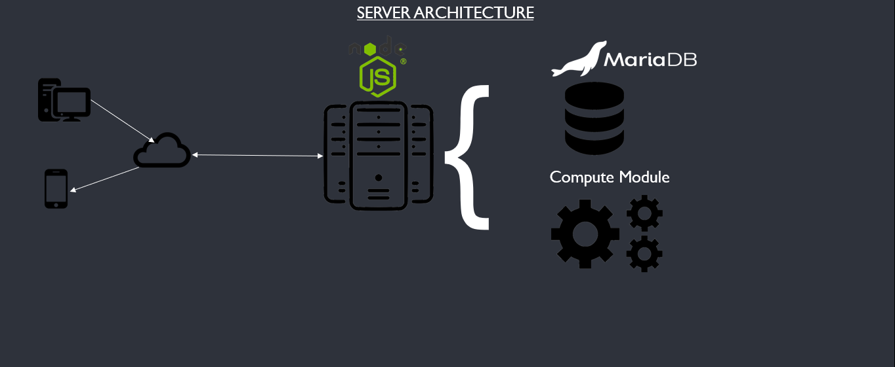

Figure 5: Server Technologies

It runs a MariaDB, a Relational Database Management System (RDBMS), that is discussed in detail in the database design section.

On top of that, it is the main compute module that is used to handle the critical operations of the system such as determining whether or not a client is within range of a broadcast range using Haversine distance.

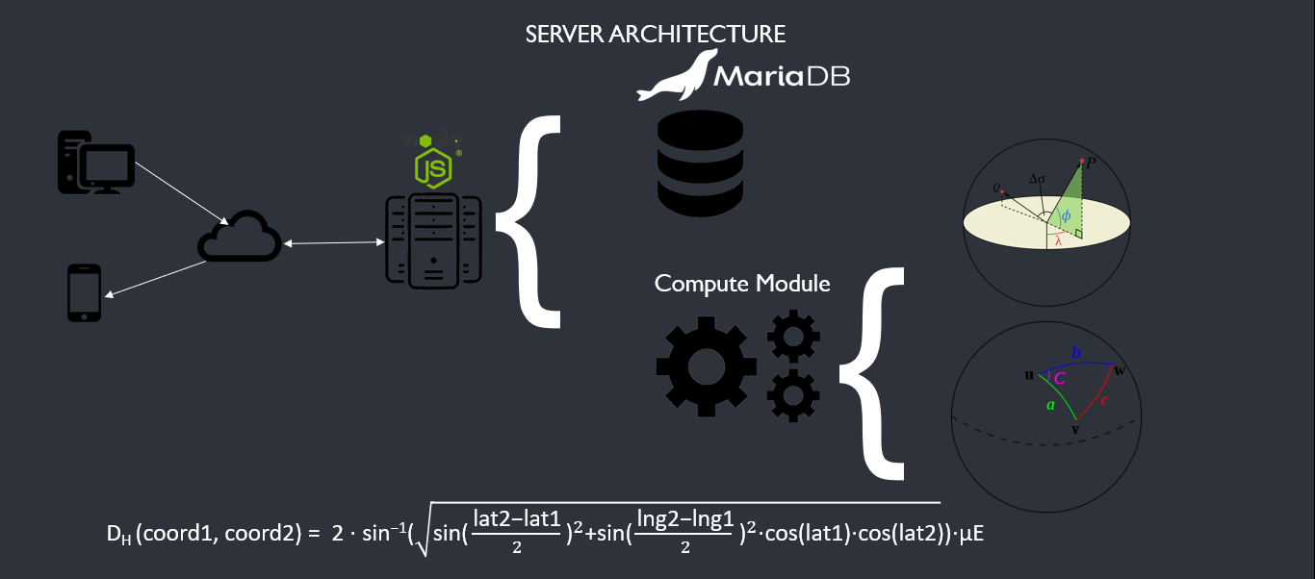

Figure 6: Compute Module Example

* Client Technologies

The client technologies include an emulated android development environment on Android Studio.

It runs on an android operating system running on Kotlin that offers compute logic.

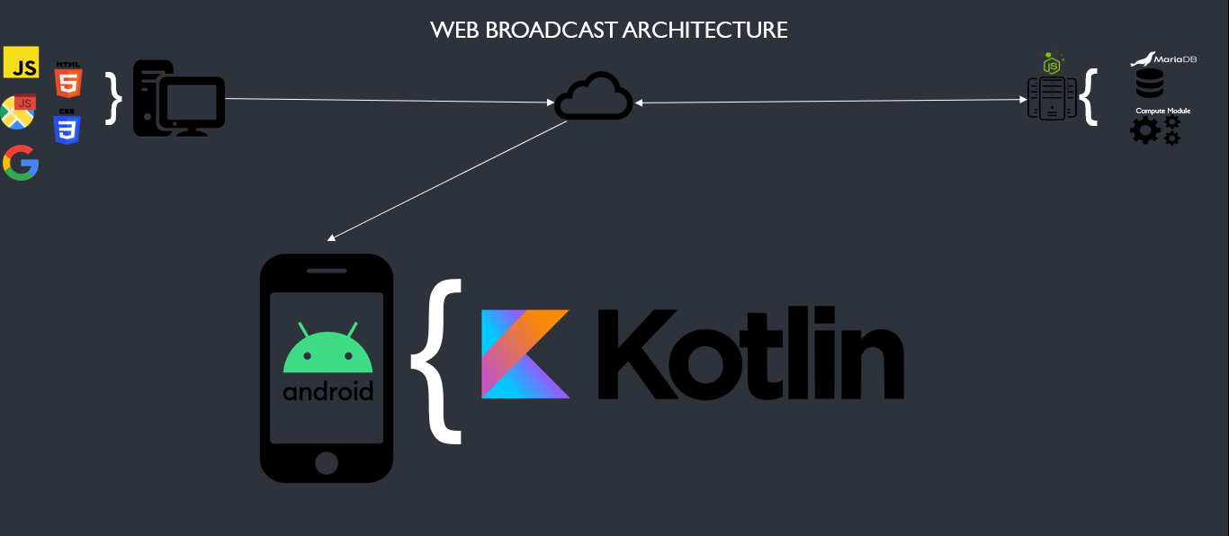

Figure 7: Client Technologies

* Web Platform Technologies

The web platform technologies include the typical web development stack i.e., HTML 5, CSS 3 and JS but with the inclusion of the Google Maps JS API that enables visualization of data on a real world map.

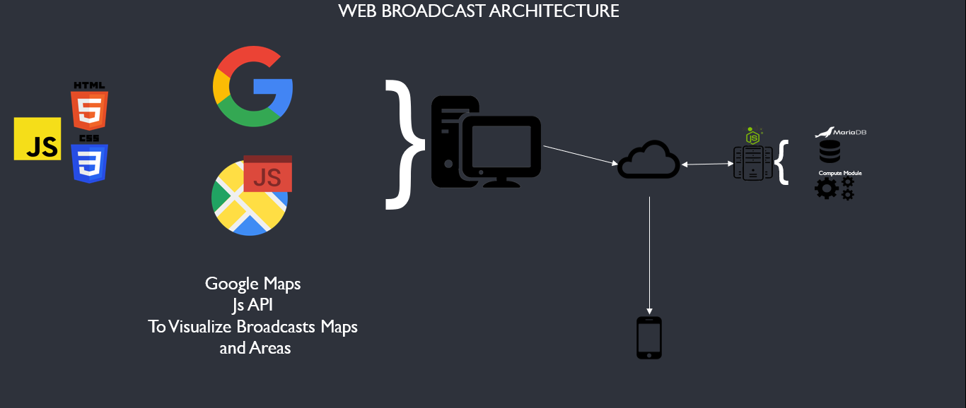

Figure 8: Web Technologies

DATABASE DESIGN

The design for the database can be described by the schema below.

UI DESIGN

Web Platform Design

The web platform Design approach was to dynamically load different sections of the web platform to a main content pane when a particular selection is made.

It consists of data input forms that support singular or csv data uploads and a lower navigation bar that performs the broadcast commands.

Mobile Client Design

The mobile client design is a simple activity windows that renders the emergency message on a white background.

It pops up when the application is ran and returns the most recent emergency message broadcasted that was intended to reach the particular client.

REFERENCES

Communications Authority of Kenya Annual Report and Financial Statements 2020-2021. (n.d.). In *www.ca.go.ke*. <https://www.ca.go.ke/document/annual-report-financial-year-2020-2021/>

Aitsi-Selmi, A., Egawa, S., Sasaki, H., Wannous, C., & Murray, V. (2015). The Sendai Framework for Disaster Risk Reduction: Renewing the Global Commitment to People’s Resilience, Health, and Well-being. *International Journal of Disaster Risk Science*, *6*(2), 164–176. https://doi.org/10.1007/s13753-015-0050-9

Preparedness, E. (2018). Communicating risk in public health emergencies: a WHO guideline for emergency risk communication (‎ERC)‎ policy and practice. *www.who.int*. <https://www.who.int/publications/i/item/9789241550208>

APPENDIX A: USER MANUAL

APPENDIX B: SAMPLE CODE